Vice President,
Finance and Administration

Ursuline College (www.Ursuline.edu), seeks a committed, visionary, experienced leader to serve as Vice President of Finance and Administration.

Reporting to the President and serving as a member of President’s Council, the position:
- provides strategic leadership and direction in the administration of financial and facility operations

- supervises and directs all activities of the Business Office, Human Resources, and Facilities

- serves as the CFO and is the formal Treasurer and Secretary of the College

- works closely with the Board of Trustees, including the committees of the Board

In an institution with a richly diverse student body, the Vice President for Finance and Administration must value and promote diversity and inclusion, in action as well as thought.

OVERALL JOB FUNCTIONS:

- Collaborate with the President and President’s Council to advance the goals of the College, develop strategic plans, and lead the overall financial management of the College.
- Develop relationships with outside professionals in the areas of audit, banking, investment, insurance, employee benefit programs, compliance, risk management and facilities management.
- Incorporate leading practices and growth initiatives in a strategic manner.
- Promote a culture of continuous improvement that values learning and a commitment to quality.
- Direct, assist, and instruct staff as to methods, procedures, and standards of performance.
- Perform other duties necessary to promote the College’s mission and growth.

FINANCE OPERATIONS:

- Incorporate leading trends in higher education and finance to strengthen the financial health of the College.
- Provide administrative support to the Investment and Finance committees of the Board of Trustees. Attend committee and Board of Trustee meetings to report on financial, facilities and investment results as required.
- Formulate and recommend policies and programs to establish and improve financial affairs, financial reporting, and internal controls.
- Manage and direct operational accounting services, such as accounts receivable, accounts payable, payroll, cash management, investment, employee benefits, and insurance, including health, property, and liability.
- Manage financial reporting systems, including preparation and analysis of monthly financial statements and annual audited financial statements. Prepare governmental and other reports and tax returns.
- Plan, coordinate, and manage the annual budget process with Budget Council.
- Support Human Resources programs and policies including compensation structure, employment practices, and employee benefit programs.
- Monitor investments such as endowment and other restricted funds, within investment and spending policy established by Board of Trustees.

FACILITY OPERATIONS:

- Manage and direct operational facility services, including maintenance, housekeeping, mailroom, print shop, central purchasing, vending, rental space, telecommunications, and security. Oversee energy conservation and savings.
- Provide administrative support to the Buildings and Grounds committee of the Board of Trustees. Attend committee and Board of Trustee meetings to report on planning, construction, and capital improvements as required.
- Oversee Emergency Preparedness Plan and ensure that requirements for related federal reports are met.
- Be responsible for Master Plan of the future needs of the College.
- Oversee all new major and minor construction projects.

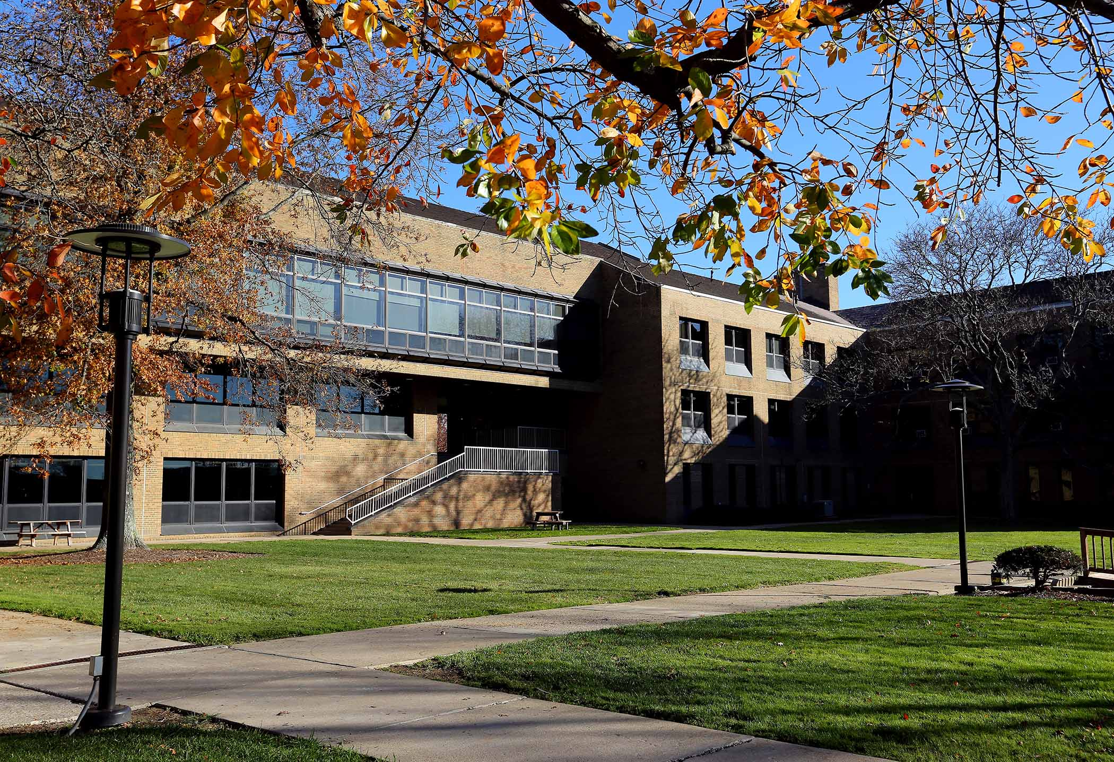

QUALIFICATIONS:

- Bachelor’s degree in accounting/finance or equivalent required.
- Master’s degree preferred.
- CPA or equivalent work experience required.
- Human resources experience preferred.
- Facilities management experience required.
- Seven to ten years’ experience in higher education finance, or a non-profit institution, with evidence of initiative and leadership success in the finance/accounting area.
- Experience in implementing and maintaining budgeting and accounting systems in ERM platforms.
- Strong communication and supervisory skills.
- Ability to consistently perform duties in a manner supportive of the mission of Ursuline College and its values and philosophy.

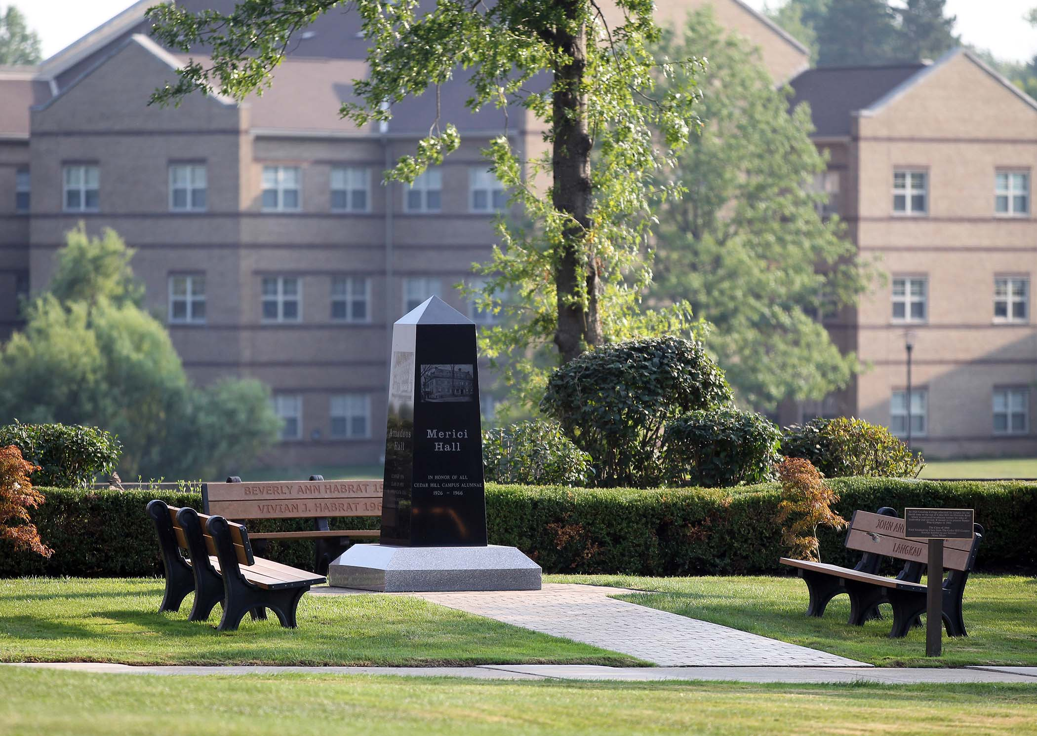

ABOUT URSULINE COLLEGE:

The Mission of Ursuline College is to offer holistic education that transforms students for service, leadership and professional excellence by providing undergraduate and graduate programs that foster lifelong learning and personal wisdom in an environment characterized by a Catholic and Ursuline heritage, women-centered learning, values-based curricula, and inclusive, global perspective.

Ursuline College was established in Cleveland in 1871 by Ursuline Sisters. As the first Catholic college for women in Ohio and one of the first in the United States, Ursuline, with an enrollment of 1,100 students, 90% female, is now the single women-focused college in the state.

Committed to excellence, the College enjoys the richness of an inclusive community, with a third of the student body from underrepresented groups. Diversity is an essential element of the College’s Catholic and Ursuline heritage. Under an academic structure with two Schools and the Ursuline College Accelerated Program (UCAP), the College offers 22 undergraduate majors, 6 Master’s degrees, numerous post-baccalaureate certificates, and a Doctor of Nursing Practice (DNP). A member of the Great Midwest Athletic Conference in NCAA Division II, the College hosts 12 athletics teams, plus a wide range of student activities as opportunities for student development and leadership. Ursuline is accredited by the Higher Learning Commission of the North Central Association of Colleges and Schools and by accrediting bodies in business, education, nursing, and counseling and art therapy.

Ursuline College is being assisted by the partners of Hyatt-Fennell. Submit nominations and application materials to Cheryl Hyatt at Ursuline@hyatt-fennell.com. Applications include a letter of interest, a current résumé/cv, and contact information for five professional references. Applications will be reviewed as they are received and should be submitted prior to January 4, 2021 to receive full consideration. All applications and nominations will be considered highly confidential.
For more information contact:
Cheryl Hyatt – 724-242-0476
Ursuline@hyatt-fennell.com
www.HYATT-FENNELL.COM

